

SRI LANKA INSTITUTE OF INFORMATION TECHNOLOGY

[**Enterprise Standards and Best Practices for IT Infrastructure**](http://courseweb.sliit.lk/course/view.php?id=137)

**4th Year 1st Semester 2016 (June Intake)**

Name: N.A.I. Dhanushka

SLIIT ID: IT13136666

Practical Session: <WD >

Practical Number : <Lab 3>

Date of Submission: 30/07/2016

Date of Evaluation : _____________________

Evaluators Signature : _____________________

**Launch a DB Instance**

Select the “RDS (Managed Relational Database Service)”

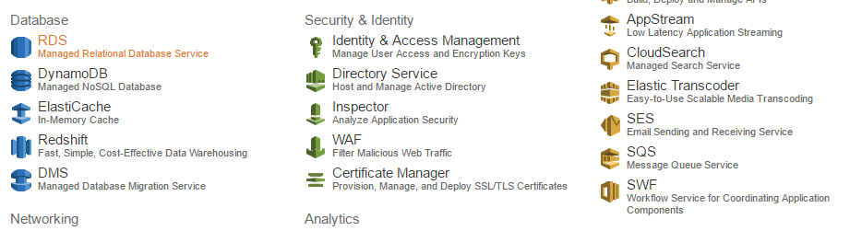

You see this interface

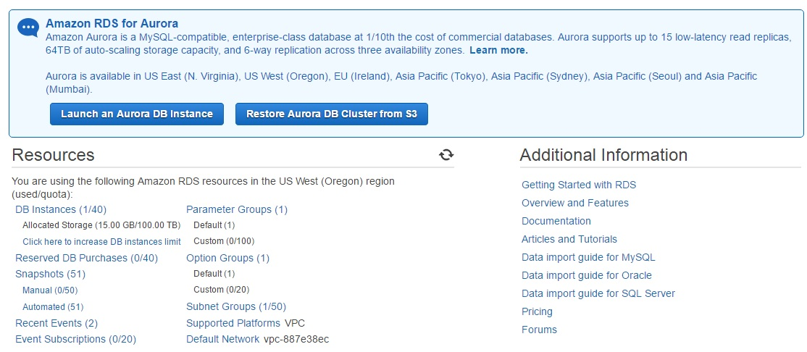

Below Create Instance click “Launch a DB Instance”

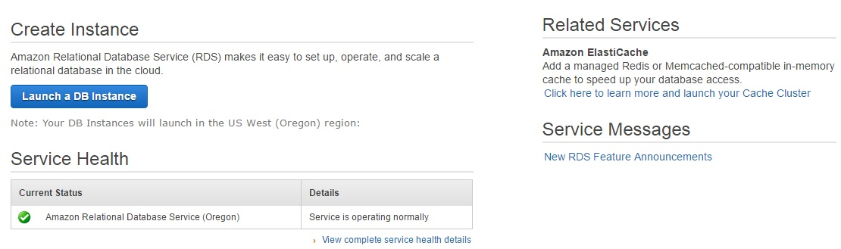

Select “MySQL” and click “Select”

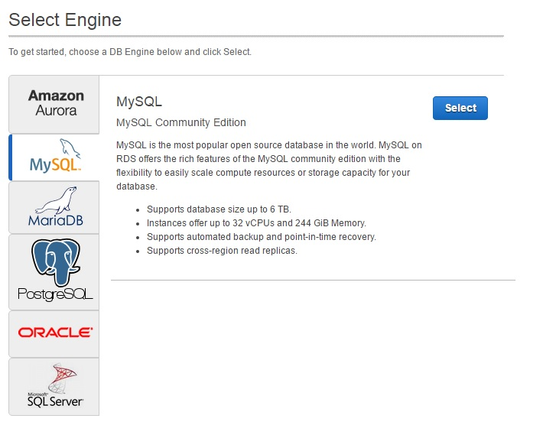

After Under Instance Specification you have to change “DB Instance Class” shown below

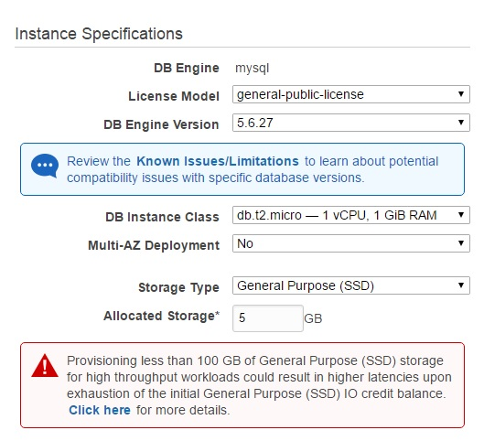

Under Setting you have to fill this and Click “Next Step”

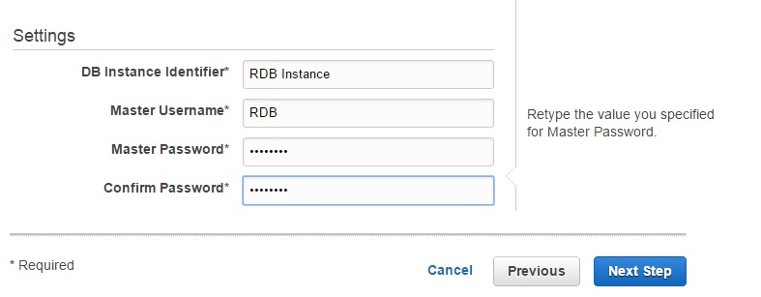

Then Configure Advanced Settings

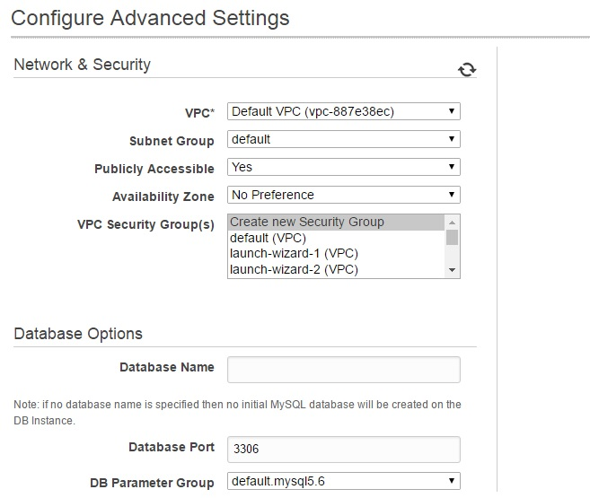

Click “Launch DB Instance”

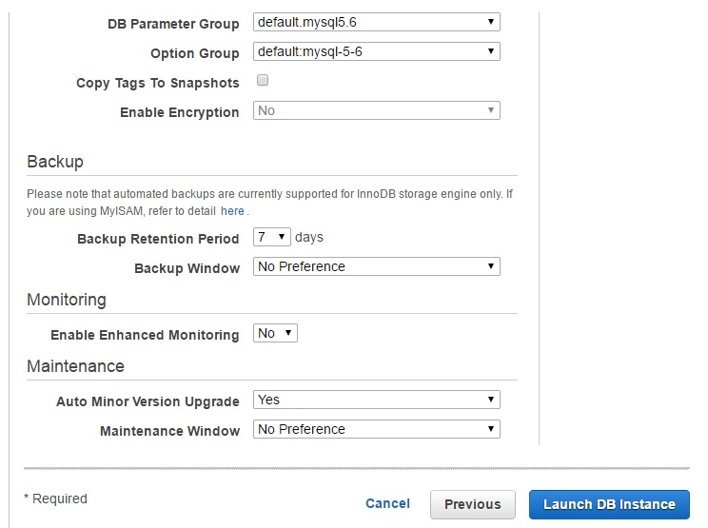

Then

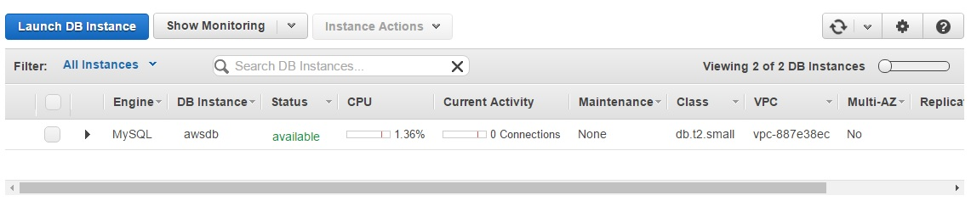

Go to My SQL “Database” under “Connect to Database”

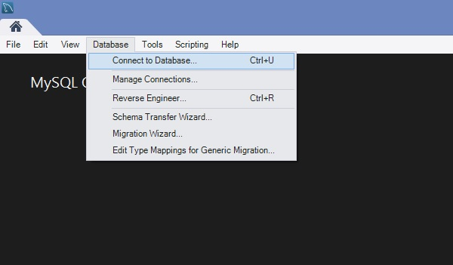

Then we have to change “Host name” Go to DB Instances Details and copy the “End Point” and paste “Host name” Text box and give the “Username” after click “Store in Vault”

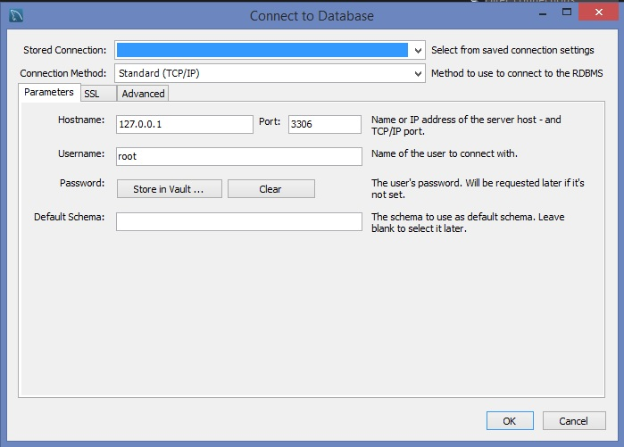

Then give the “Password” and click “Ok”

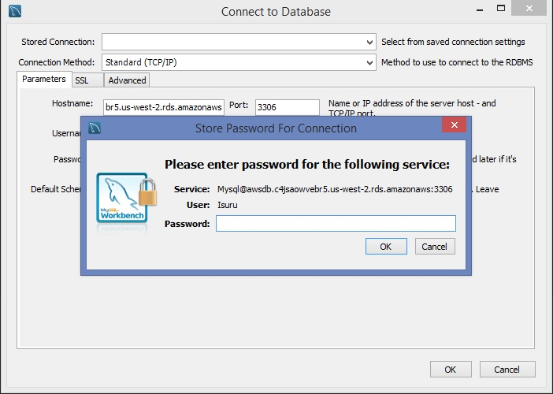

Opening SQL Editor

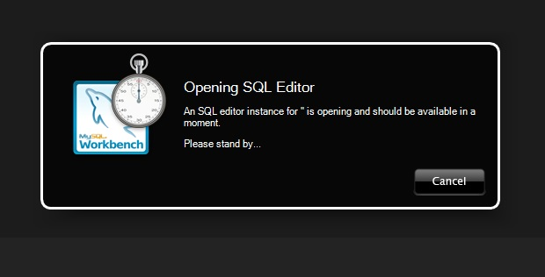

Now you can You MySQL Workbench

